Viewing LogicalCHOICE eBook/ePub Files

Logical Operations eBooks are distributed as ePub files. ePub is an industry standard file format that can be viewed on any PC/Mac, iOS, or Android device (among several other different types of devices).

To ensure an efficient learning experience, training organizations or end users should install an eReader application capable of viewing ePub files before utilizing the LogicalCHOICE learning platform. Recommended applications for viewing ePub files are listed below:

Device | Recommended Reader
PC/Mac | Adobe Digital Editions
iOS | iBooks
Android | Bluefire, MyLibrary or default ePub reader installed on the device

After the appropriate application has been installed, please reference device-specific instructions below for further information on viewing ePub files on your local device. Users can scan to the instructions for their device by selecting the device in the table above.

PC/Mac

Adobe Digital Editions is the reader Logical Operations recommends for viewing ePub files on a PC or a Mac computer. Adobe Digital Editions is a free application that allows users to view ePub and PDF files. This application can be downloaded here: http://www.adobe.com/products/digital-editions/download.html. After downloading the application, users should follow the guidelines below to view their eBook.

- To view the eBook, log-in to the LogicalCHOICE platform and select the eBook tile:

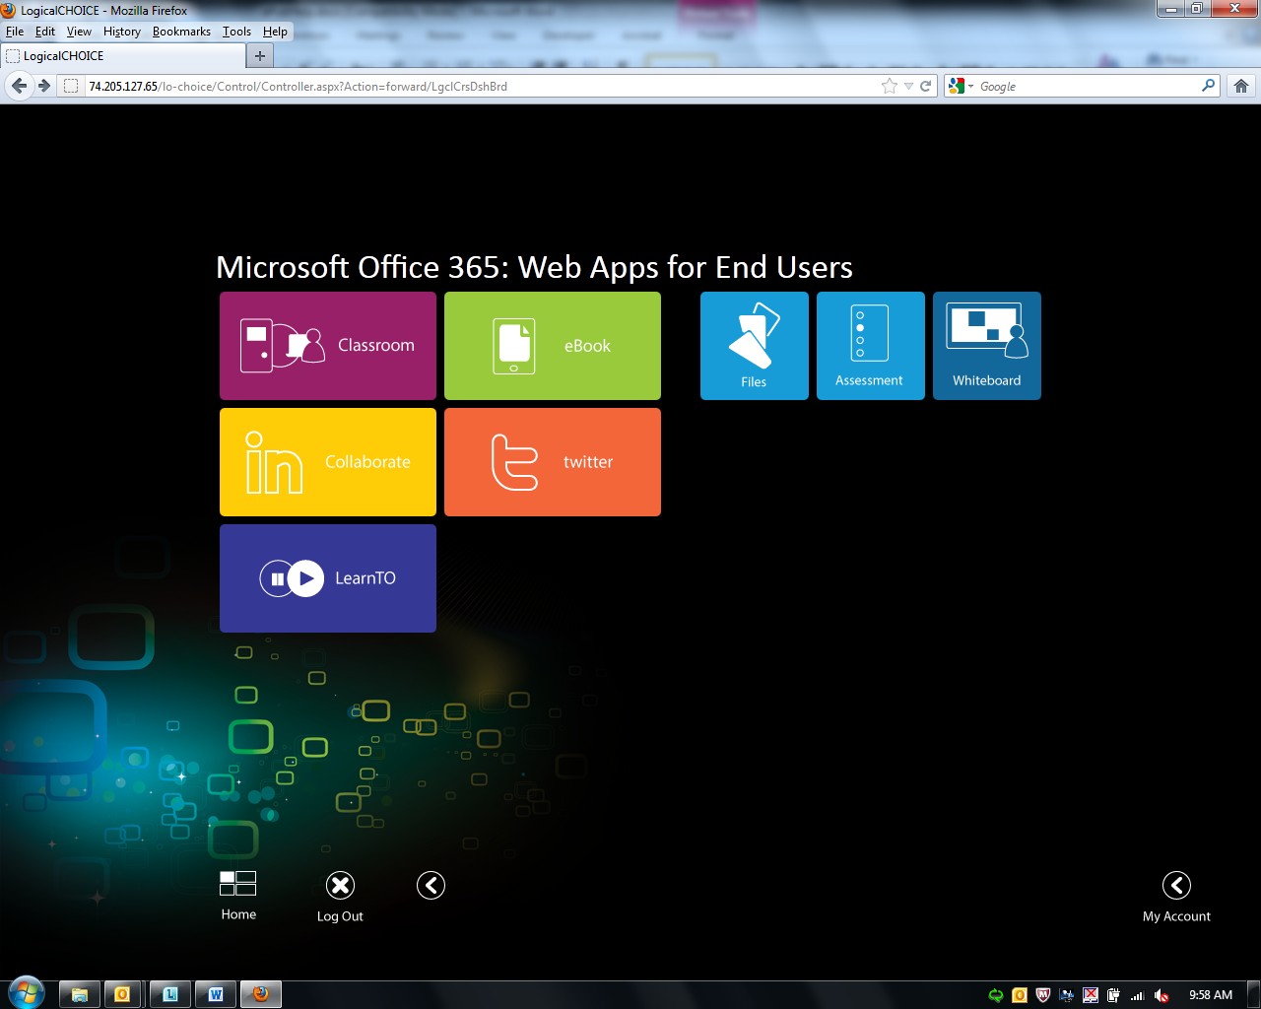

- After selecting the tile, open or save the ePub file.

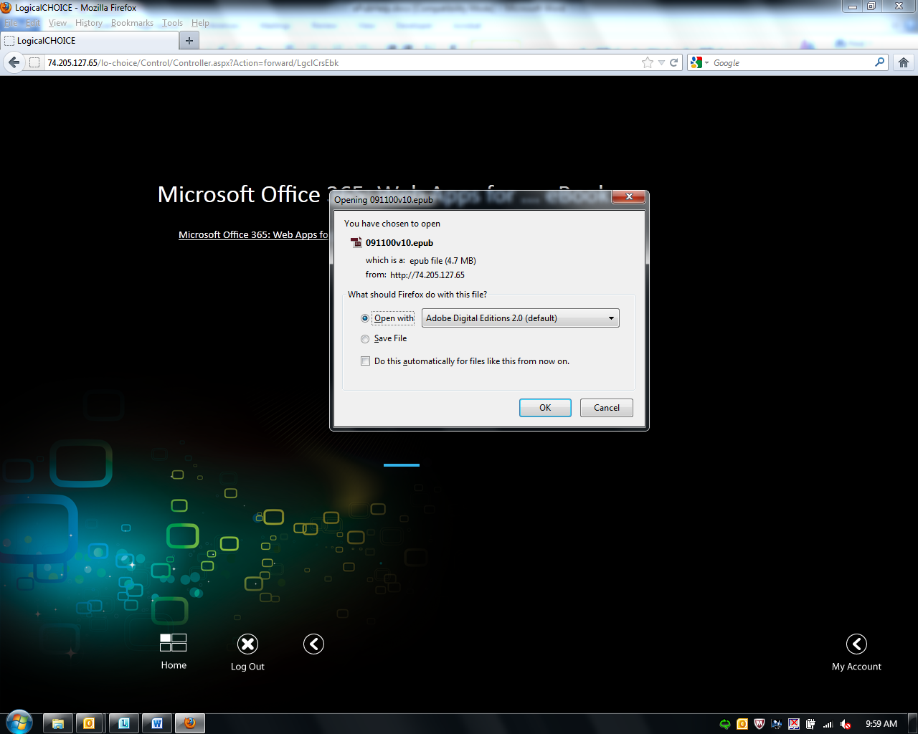

If users choose “Open with”, they can view the ePub file right away, but it will not be saved to their Adobe Digital Editions library. Once open, users can add the title to their Digital Editions Library by clicking the “Copy to Library” button. Digital Editions will then save a copy of the file in the “… Documents\My Digital Editions” directory. The file must be added to the user’s library in order to use any of the annotation features.

- Once added to the Digital Editions Library, users can read, create bookmarks, and even highlight key text within Digital Editions. The eBook is now on the user’s local drive and will not need to be downloaded again.
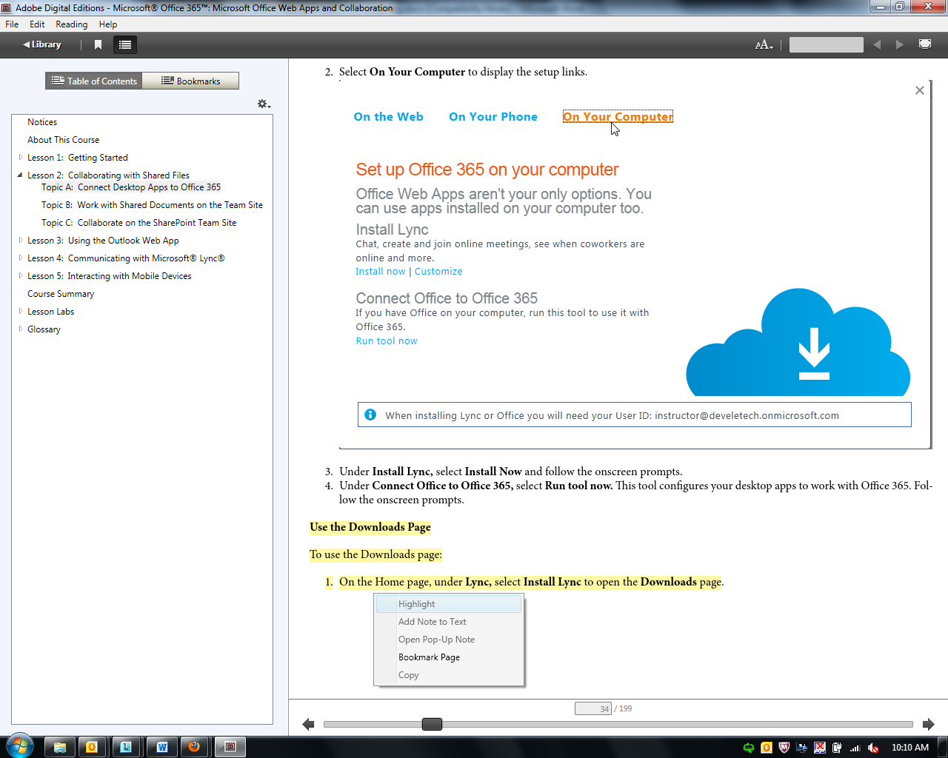

iOS

iBooks is the reader Logical Operations recommends for viewing ePub files on an iOS device. iBooks can be download for free in the Apple store. After downloading the application, users should follow the guidelines below to view their eBook.

- To view the eBook, log-in to the LogicalCHOICE platform and select the eBook tile:

- Next, select the eBook link.

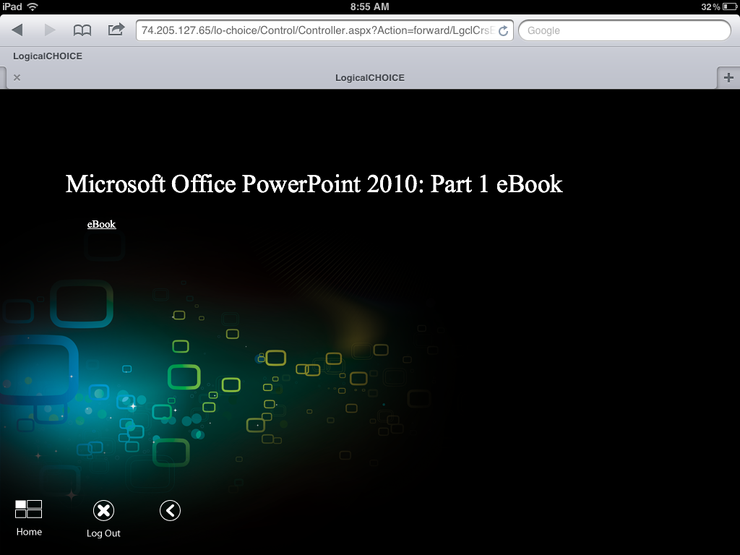
- After clicking the eBook link, users will be prompted to open the ePub file in iBooks (recommended) or another app (if installed).

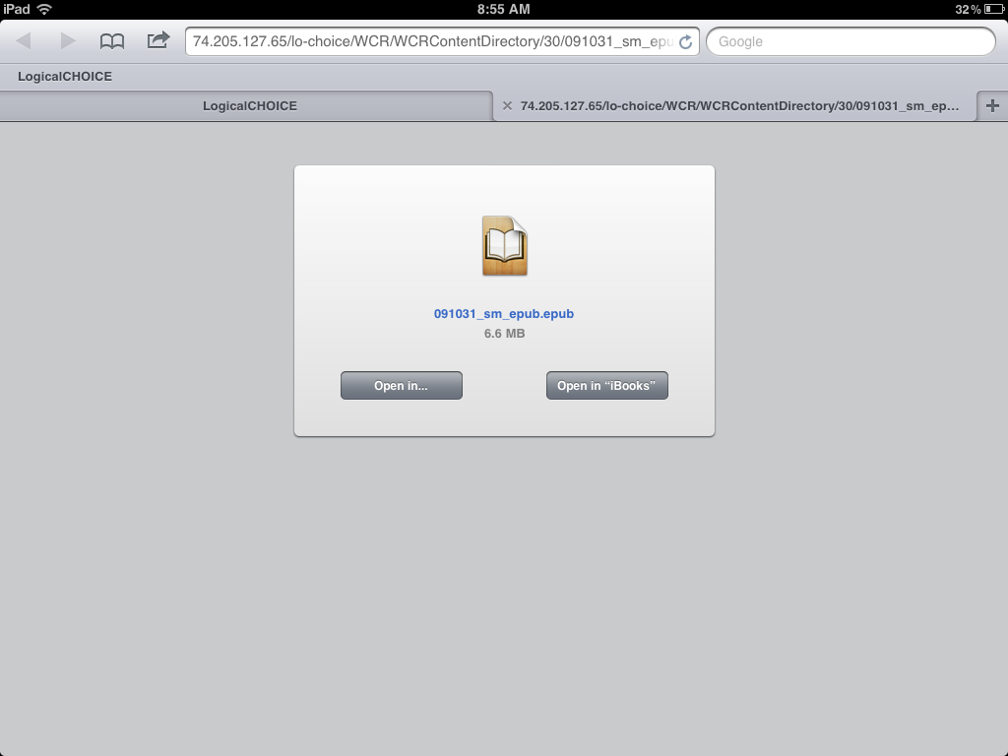

- For other reader apps, the screen will look similar to below. Most readers will open and download automatically, as well as add the eBook to the library for that reader app.

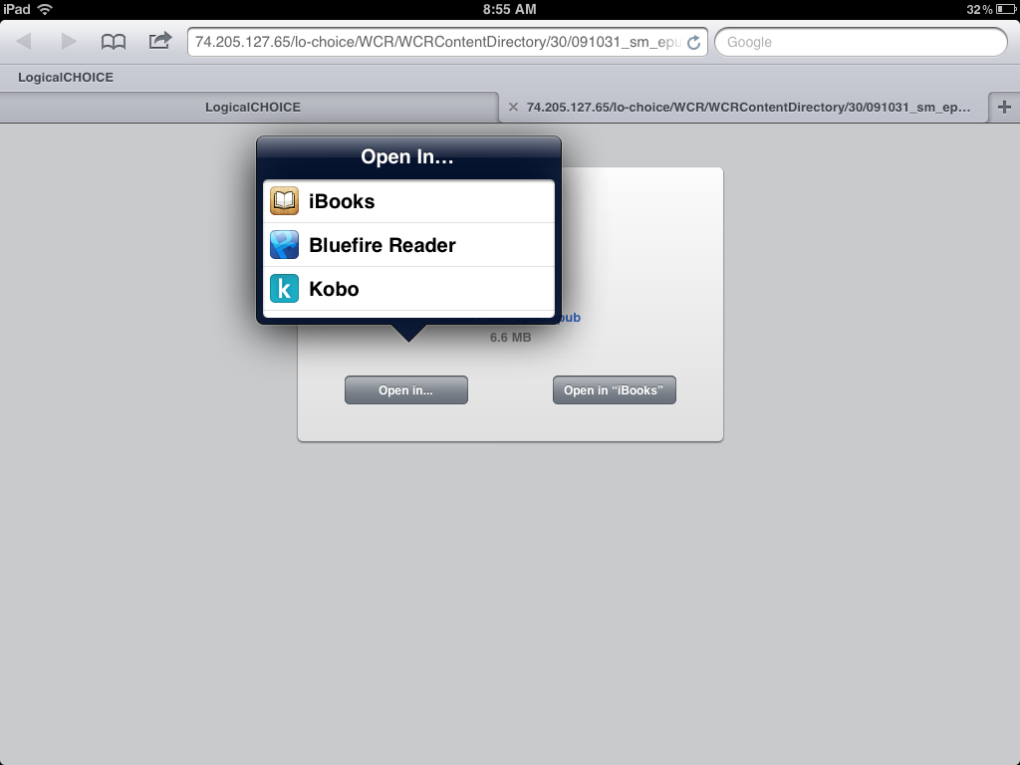

- If using iBooks, the app will download the ePub file to the iBooks library and open automatically.

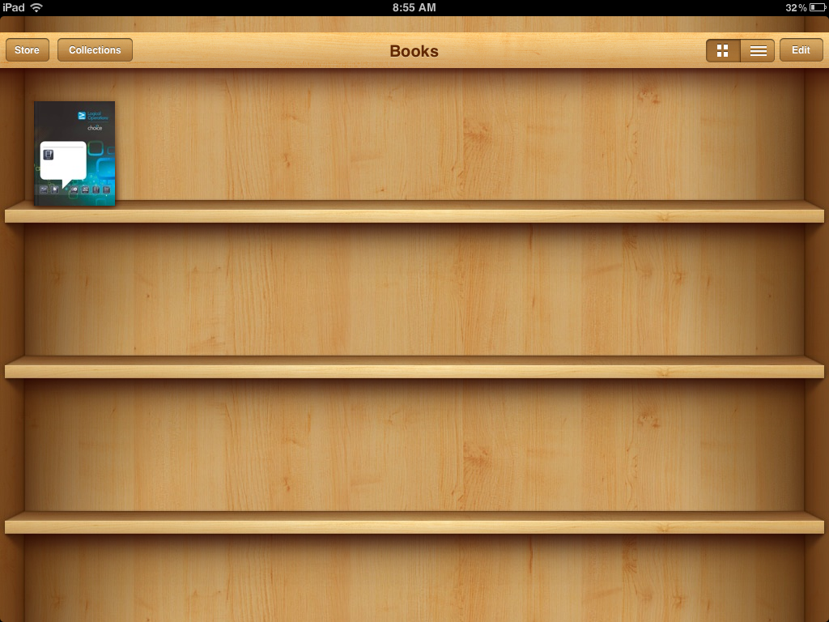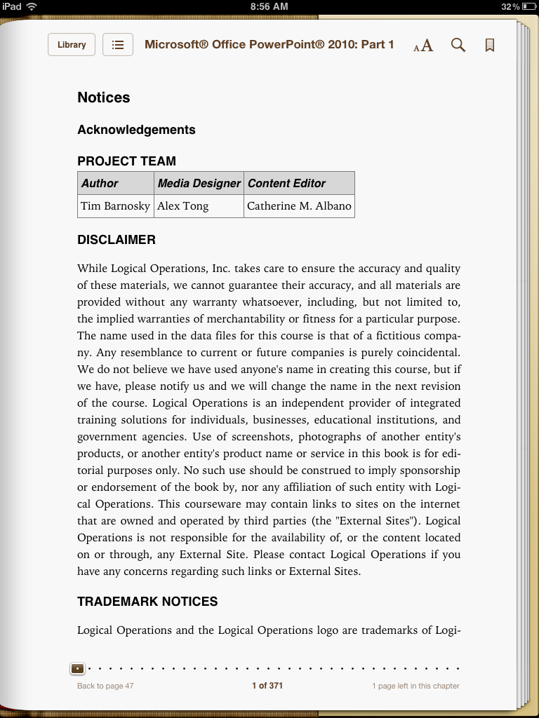

- If using a different app, a similar process will occur, but users may need to open the file themselves after the initial download.
- The eBook is now on the user’s local drive and will not need to be downloaded again.

Android

Bluefire or MyLibrary are the readers Logical Operations recommends for viewing ePub files on an Android device. These readers can be downloaded for free off the Android market. After downloading the application, users should follow the guidelines below to view their eBook.

- To view the eBook, log-in to the LogicalCHOICE platform and select the eBook tile:

- After selecting the tile, open the ePub file.

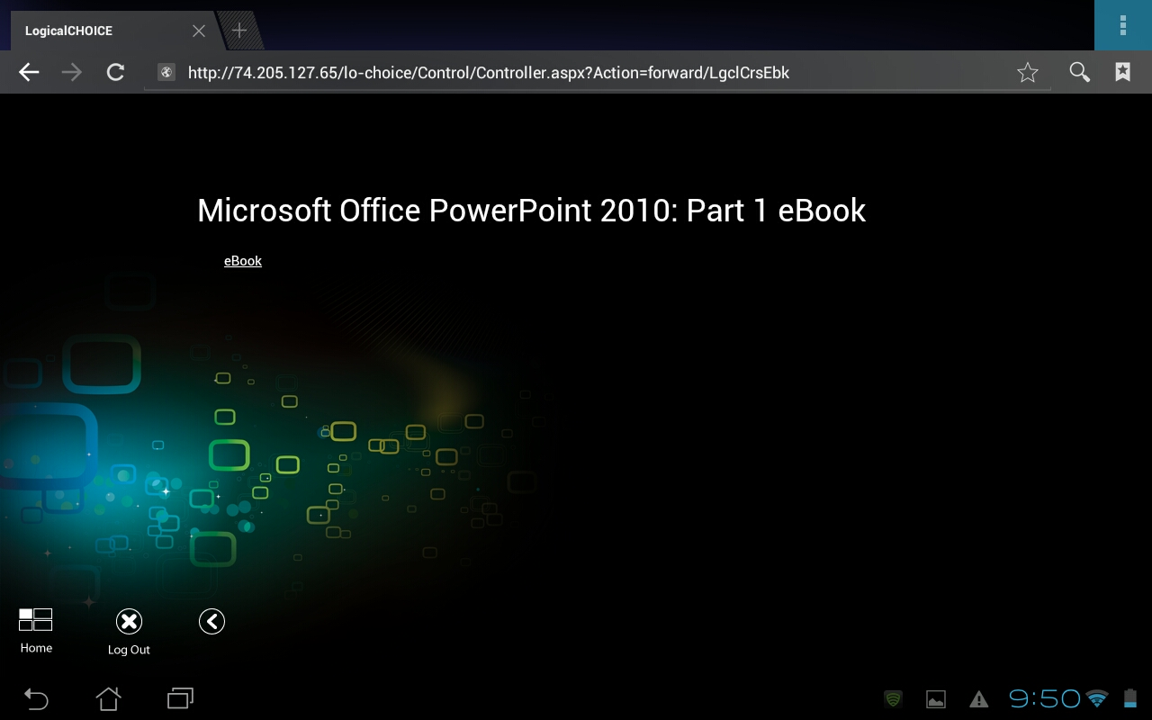

- Most Android readers will open and download the ePub file automatically, as well as add the eBook to the library for that reader app.

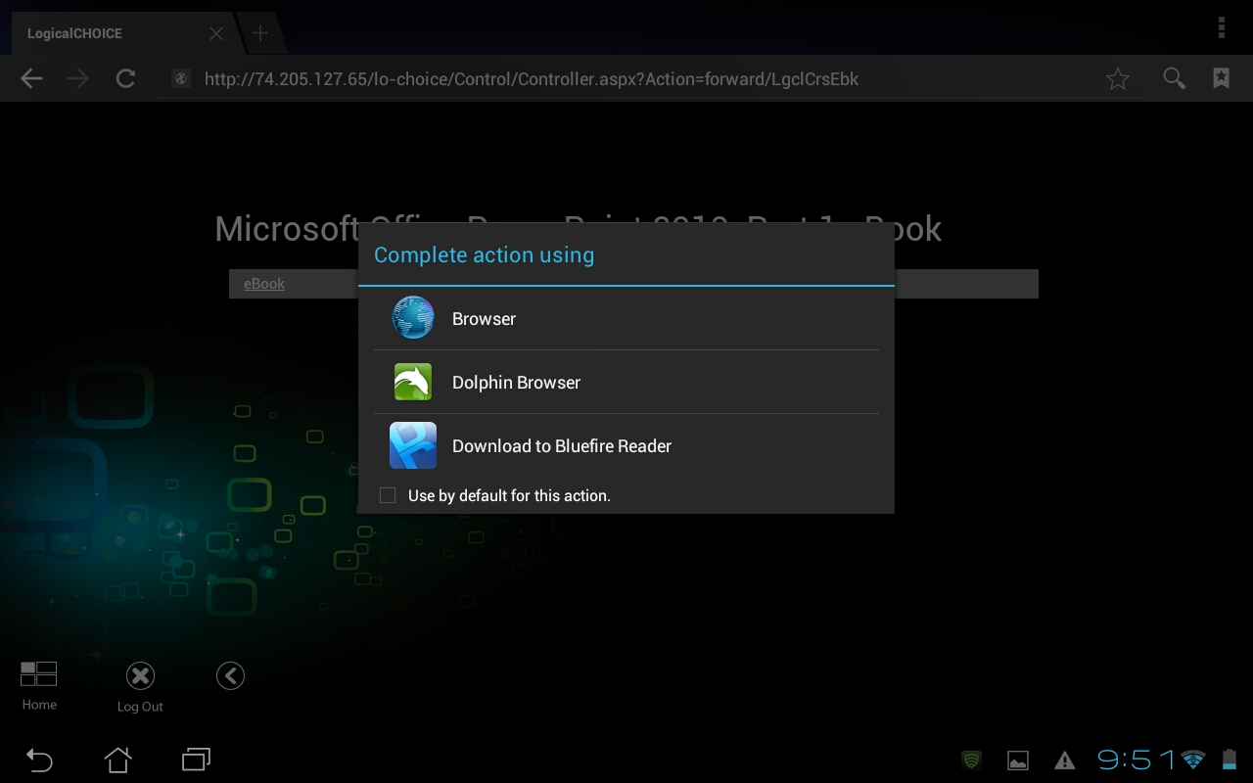

- With Bluefire, users have the option of going to the library and opening the file themselves or opening the file right away.

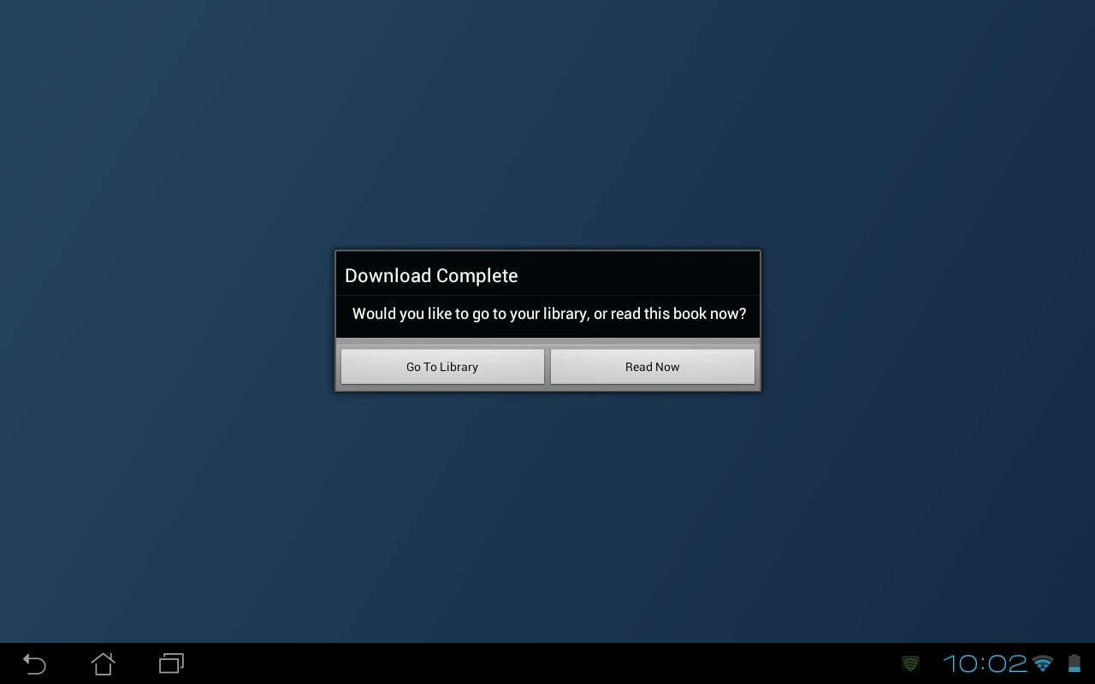

- If using a different app, a similar process will occur, but users may need to open the file themselves after the initial download.
- The eBook is now on the users local drive and will not need to be downloaded again.

